

Data-Driven Insights for Supermarket Performance Improvement

University of Oulu
Data Analytics and Business Intelligence
Blessing Osazuwa
2025
Word count: 650

TABLE OF CONTENTS
1. INTRODUCTION 4
1.1. Panopto Link 4
1.2. Excel Link 4
2. DATASET OVERVIEW 4
2.1. Data Cleaning and Preparation 4
2.2. Data Analysis Methodology 5
3. KEY FINDINGS 5
3.1. Product Line Performance 5
3.2. Branch Performance 6
3.3. Average Purchase by Customer Type 6
3.4. Payment Method Popularity 6
RECOMMENDATIONS 7
CONCLUSION 7
REFERENCES 8

INTRODUCTION
Supermarkets operate in a competitive retail environment where data-driven decisions are essential for profitability.
Small and medium-sized supermarkets often face challenges in identifying which products generate the highest revenue, which customer segments are most profitable, and how branch operations impact overall performance.
This analysis leverages transaction data to identify trends that can inform actionable strategies for increasing sales, optimizing inventory, and improving customer satisfaction.

1.1. Panopto Link
https://oulu.cloud.panopto.eu/Panopto/Pages/Viewer.aspx?id=bc5e21d0-9afd-4505-b00c-b38000f6a211

1.2. Excel Link
supermarket_sales.csv.xlsx

DATASET OVERVIEW
The analysis used the Supermarket Sales Dataset obtained from Kaggle (Supermarket Sales Dataset – Kaggle).
It contains 1,000 transactions across three branches and includes the following key fields: Invoice ID, Branch, City, Customer Type, Gender, Product Line, Unit Price, Quantity, Tax, Total Sales, COGS, Gross Income, Payment Method, Date, Time, and Customer Rating.
This dataset was chosen for its completeness, relevance, and structured format, allowing effective analysis using Microsoft Excel. It captures critical metrics needed to explore product, branch, and customer behavior, all directly influencing business decisions.

Data Cleaning and Preparation
Data cleaning steps included:
- Validation of Data Types: Ensured numerical columns and dates were correctly formatted.
- Missing Values Check: Confirmed no gaps existed
- Duplicate Removal: Verified no duplicate transactions were present.
- Derived Metrics: Created calculated fields such as average spend per customer type and gross margin percentages.
These steps ensured reliable results from pivot table aggregations and chart visualizations.

Data Analysis Methodology
All analysis was conducted in Microsoft Excel, leveraging pivot tables, basic formulas, and visualizations.
Pivot tables were used to summarize total sales, gross income, and customer counts across product lines, branches, customer types, and payment methods.
Charts including bar, column, pie, and scatter plots were created to communicate patterns clearly and facilitate interpretation for stakeholders.

KEY FINDINGS

Product Line Performance
Pivot table analysis of total sales by product line revealed that Food and Beverages is the highest revenue category, while Health and Beauty underperformed.
This visualization highlights which categories contribute most to revenue and supports decisions on promotion and inventory prioritization.
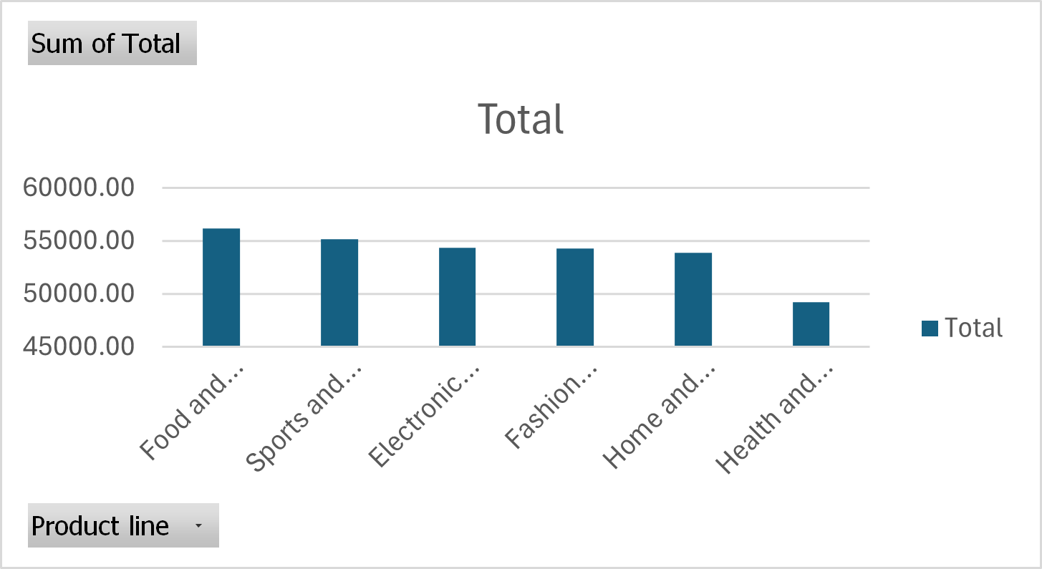
Chart 1: Column Chart - Total Sales by Product Line

Branch Performance
Pivot table summarization of gross income by branch showed Branch C consistently outperformed Branches A and B. Management can replicate Branch B’s successful strategies, such as product mix and promotions, across other locations to improve overall profitability.
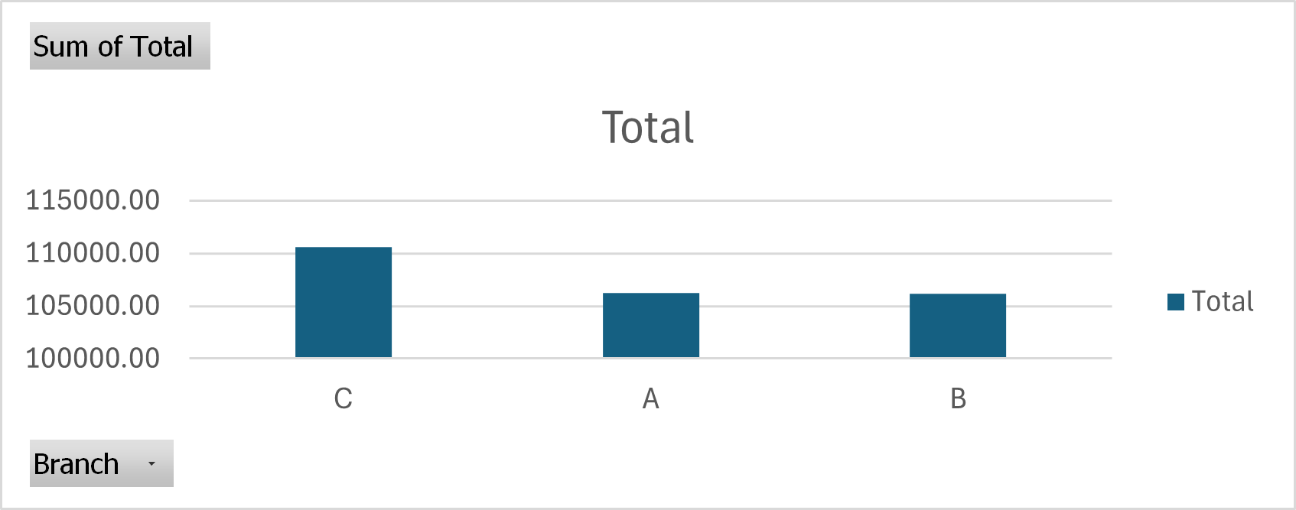
Chart 2: Column Chart - Gross Income by Branch

Average Purchase by Customer Type
Analysis of customer type and payment methods using pivot tables showed member customers spend more on average than Normal customers.
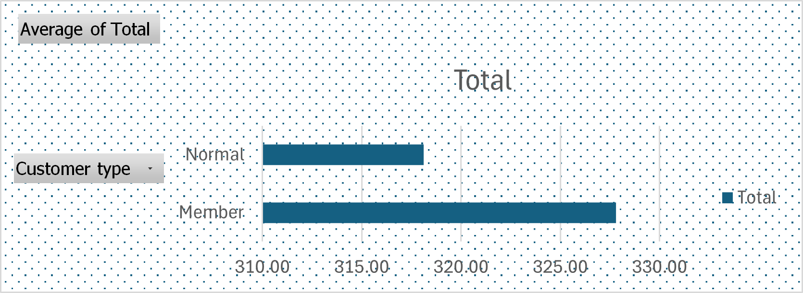
Chart 3: Pie Chart - Customer Type by Total Sales

Payment Method Popularity

E-wallet is the most popular payment method, followed by credit cards and cash. These insights suggest focusing marketing efforts on loyal members and promoting convenient digital payments to maximize revenue.
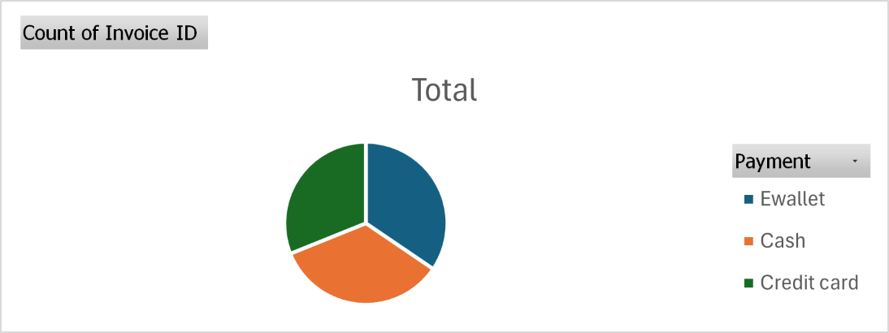
Chart 4: Pie Chart - Payment Method Distribution

RECOMMENDATIONS
Based on the analysis, the following strategies are recommended:
- Promote High-Revenue Products: Focus marketing campaigns and shelf placement on Beverages, Groceries, and other top-performing categories.
- Review Underperforming Products: Discount, reposition, or replace low-performing items to optimize inventory and reduce holding costs.
- Enhance Loyalty Programs: Engage Member customers through targeted promotions to increase repeat purchases and average spend.
- Replicate Branch B Strategies: Study operational, marketing, and customer engagement practices and apply them across other branches.
- Invest in Customer Experience: Maintain high ratings by improving service quality and store experience, which correlates with higher sales.

CONCLUSION

In conclusion, implementing these data-driven recommendations is projected to increase total sales revenue by 5-10% in the next quarter. By leveraging pivot table analysis to focus on high-margin products and successful branch strategies, management can ensure decisions are smart, evidence-based, and lead directly to improved efficiency and profitability.

REFERENCES
Aung Pyae, “Supermarket Sales Dataset,” Kaggle, 2020. Link

